**DAILY ONLINE ACTIVITIES SUMMARY**

|  |  |  |  |  |  |  |  |  |
| --- | --- | --- | --- | --- | --- | --- | --- | --- |
| **Date:** | **17/06/2020** | | | | | **Name:** | **POOJA D S** | |
| **Sem & Sec** | **4th Sem 'B' Section** | | | | | **USN:** | **4AL18CS056** | |
| **Online Test Summary** | | | | | | | | |
| **Subject** | | **…….** | | | | | | |
| **Max. Marks** | | **30** | | **Score** | | | **…..** | |
| **Certification Course Summary** | | | | | | | | |
| **Course** | **Blockchain Basic** | | | | | | | |
| **Certificate Provider** | | | **Great Learning Academy** | | **Duration** | | | **2.5 hour** |
| **Coding Challenges** | | | | | | | | |
| **Problem Statement:** A user will input two strings, and we find if one of the strings is a sub sequence of the other. Program prints “yes” if either the first string is a sub sequence of the second string or the second string is a sub sequence of the first string. Assume that, the length of the first string is smaller than or equal to the length of the second string. Assume that, the length of the first string is smaller than or equal to the length of the second string. | | | | | | | | |
| **Status: completed** | | | | | | | | |
| **Uploaded the report in Github** | | | | | **yes** | | | |
| **If yes Repository name** | | | | | <https://github.com/dspooja/C-coding> | | | |
| **Uploaded the report in slack** | | | | | **yes** | | | |

Online Test Details: (Attach the snapshot and briefly write the report for the same)

Certification Course Details: (Attach the snapshot and briefly write the report for the same)

Coding Challenges Details: (Attach the snapshot and briefly write the report for the same)

CERTIFICATION COURSE DETAILS:

* My Certification Course is Blockchain Basic
* **The concepts covered in** Blockchain Basic **are:**
* Blockchain Cryptography
* Blockchain solution
* Account, blocks, Transactions and Merkle trees
* Consensus Mechanism

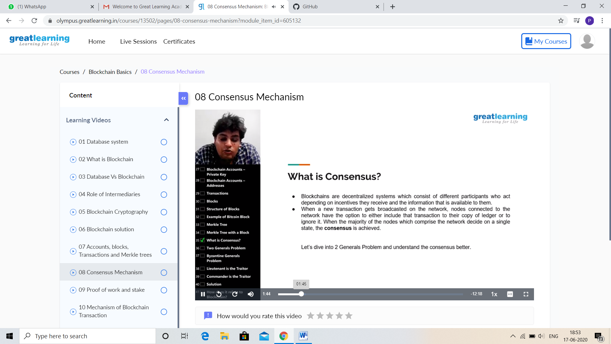

CODING CHALLENGES DETAILS:

Problem statement 1:

Write a C Program to Count numbers that don’t contain 3.

Given a number n, write a function that returns count of numbers from 1 to n that don’t contain digit 3 in their decimal representation.  
**Examples:**  
**Input:** n = 10  
**Output:** 9  
Here input is 10 means the numbers within 10 are 1,2,3,4,5,6,7,8,9,10 in this series 3 occurs only 1 times so answer is 9

**More examples**  
Input: n = 45  
Output: 31  
// Numbers 3, 13, 23, 30, 31, 32, 33, 34,   
// 35, 36, 37, 38, 39, 43 contain digit 3.

Input: n =578  
Output: 385

Solution: uploaded to github.

